## 



Customer Analysis

08.17.20XX

**─**Nicholas Rowland

Oasis Solutions, 1787 Park Place BLVD,

Las Vegas, NV 43771

**Overview** Here we will be using a number of factors across a group of people coming from a variety of backgrounds and life experiences to create a model that will predict if our target will have an income of 50k or higher in order to find our optimal market for our stakeholder(Oasis Solutions) as they would be most likely to invest in a pool installation or maintenance schedule.

# Goals

1. Create a model that features a high prediction of variance
2. Have that model prioritize true positives and prevents false positives

# Specifications

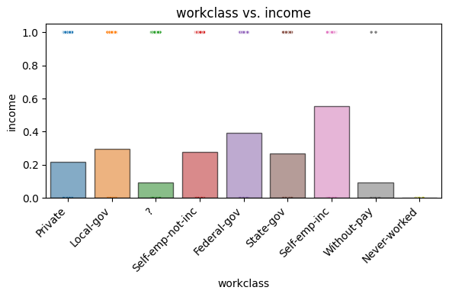 Our findings here demonstrate that self-starting influencers who start their own brands for work as well as federal-gov employees would be the most likely to qualify.

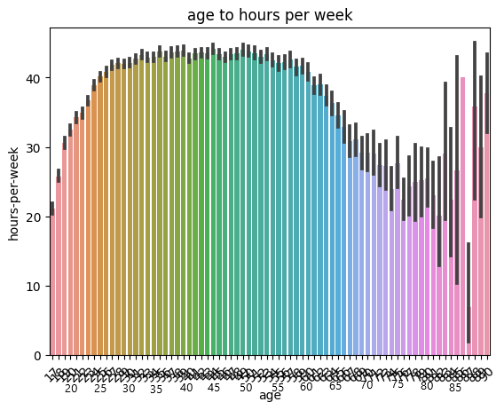

Here we can see the optimal age range we would like to market to would be between 30 and 60 while they are still working the hardest and making the most so they can qualify for the loan or even payout the pool in whole.

# Strengths/Weaknesses

This was a Classification problem to fix for our recommended model, it did the best by a considerable margin on the key metrics we wanted but left a bit to be desired on our false negatives. While not our focus it is something that could be observed further.